1.

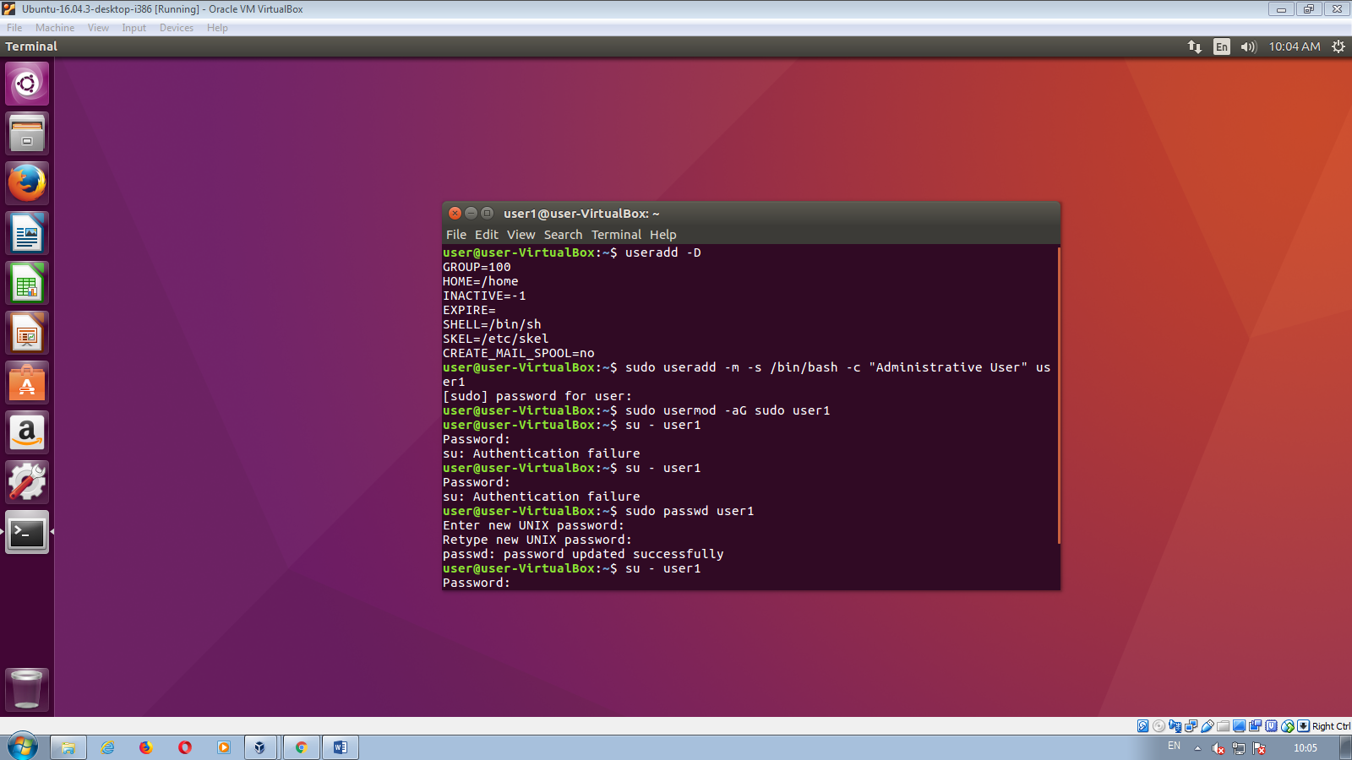  
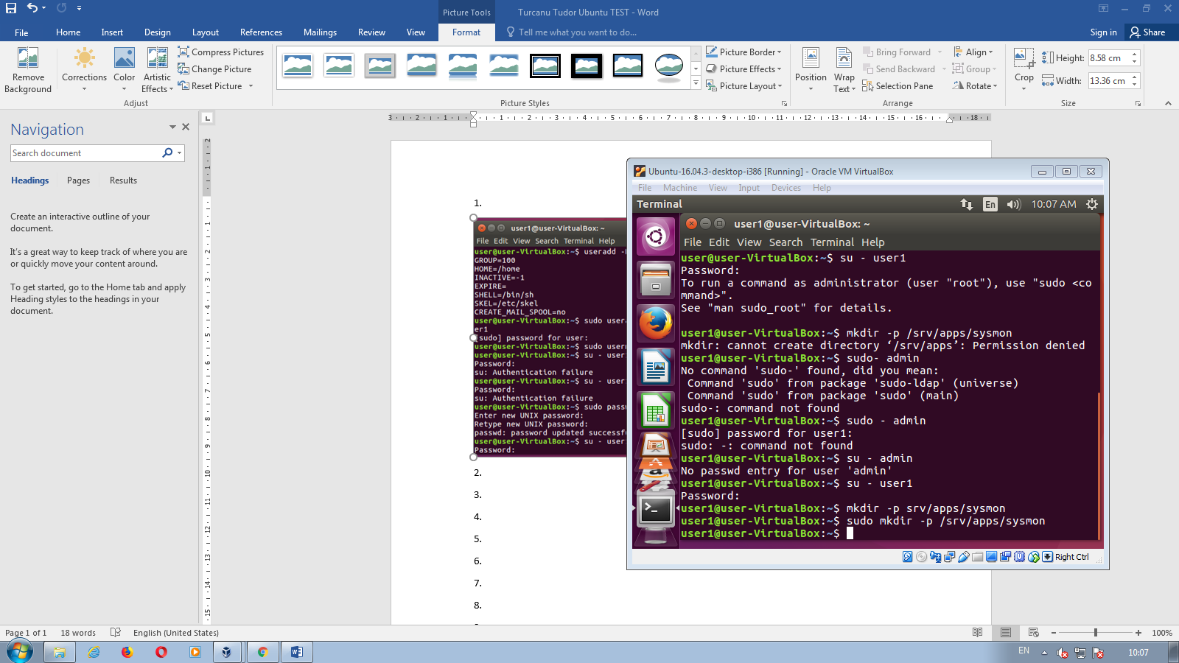

2.

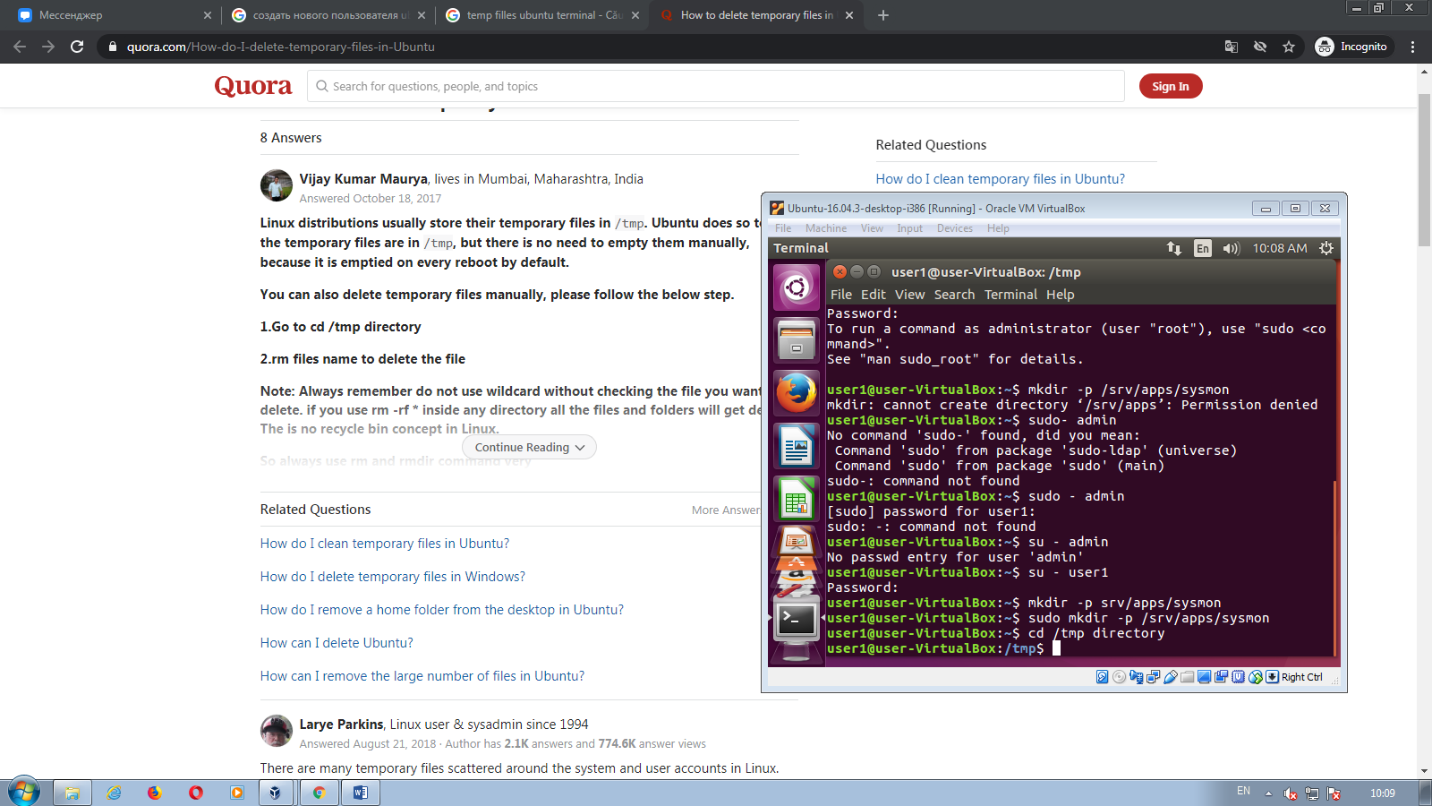

3.

Sudo apt –reinstall install locales

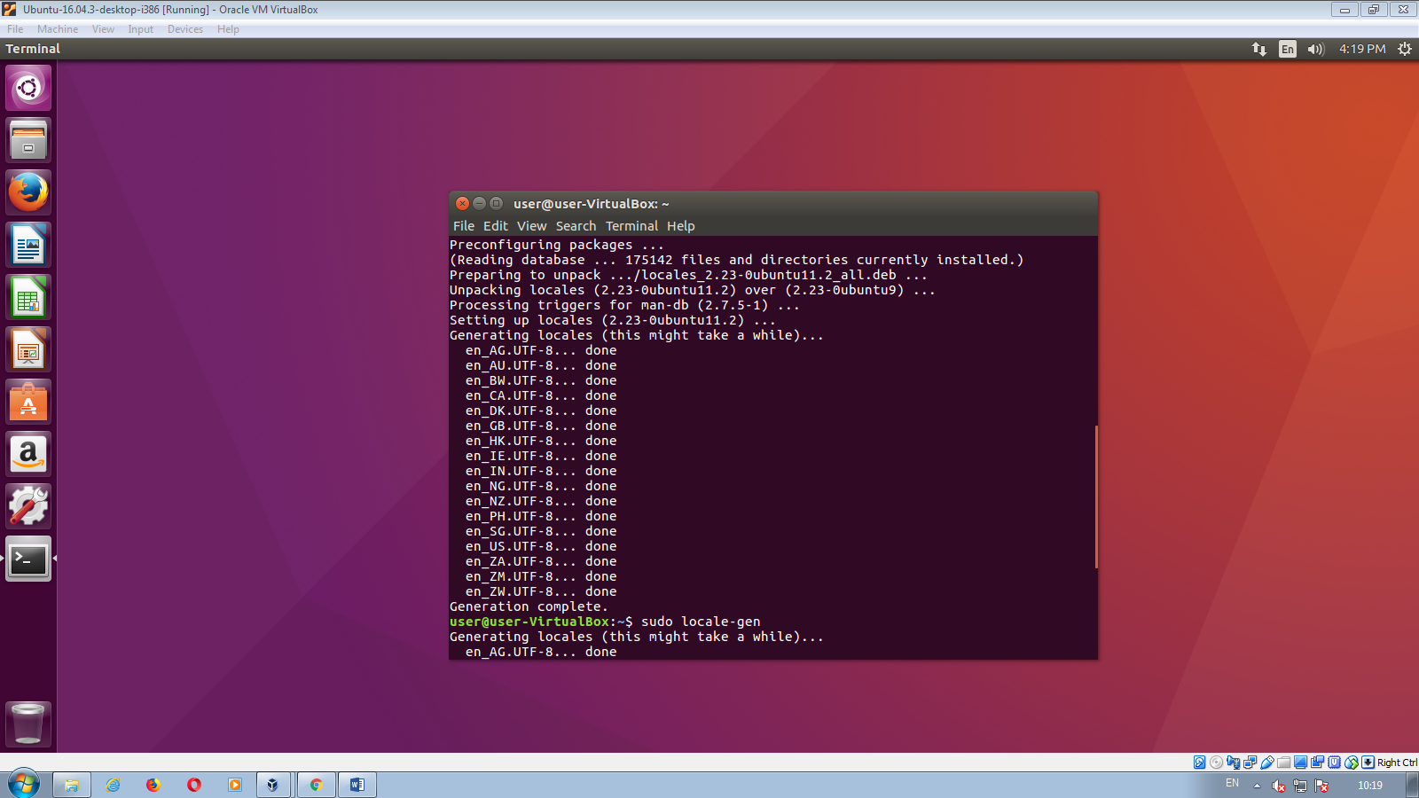

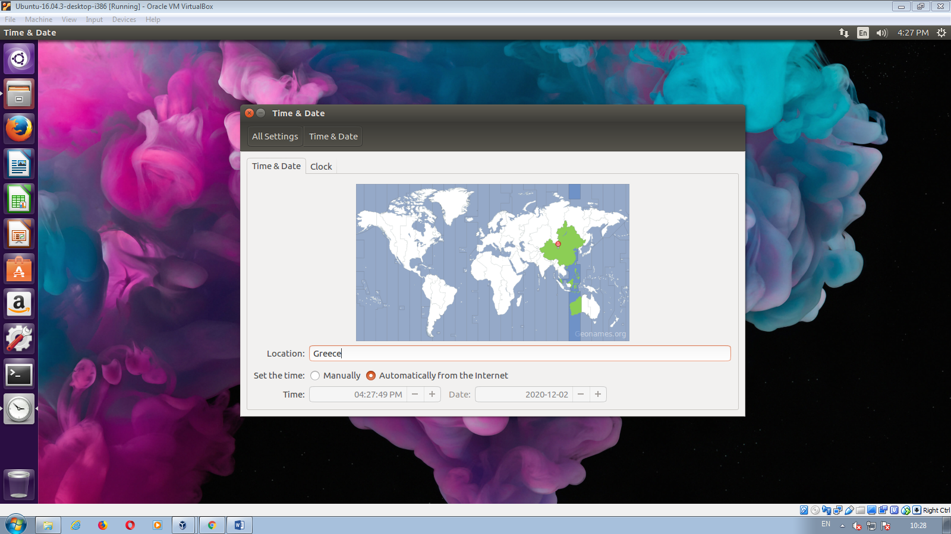

4.

:~$ gsettings set org.gnome.desktop.background picture-uri file:////home/user/DownLoads/image.png

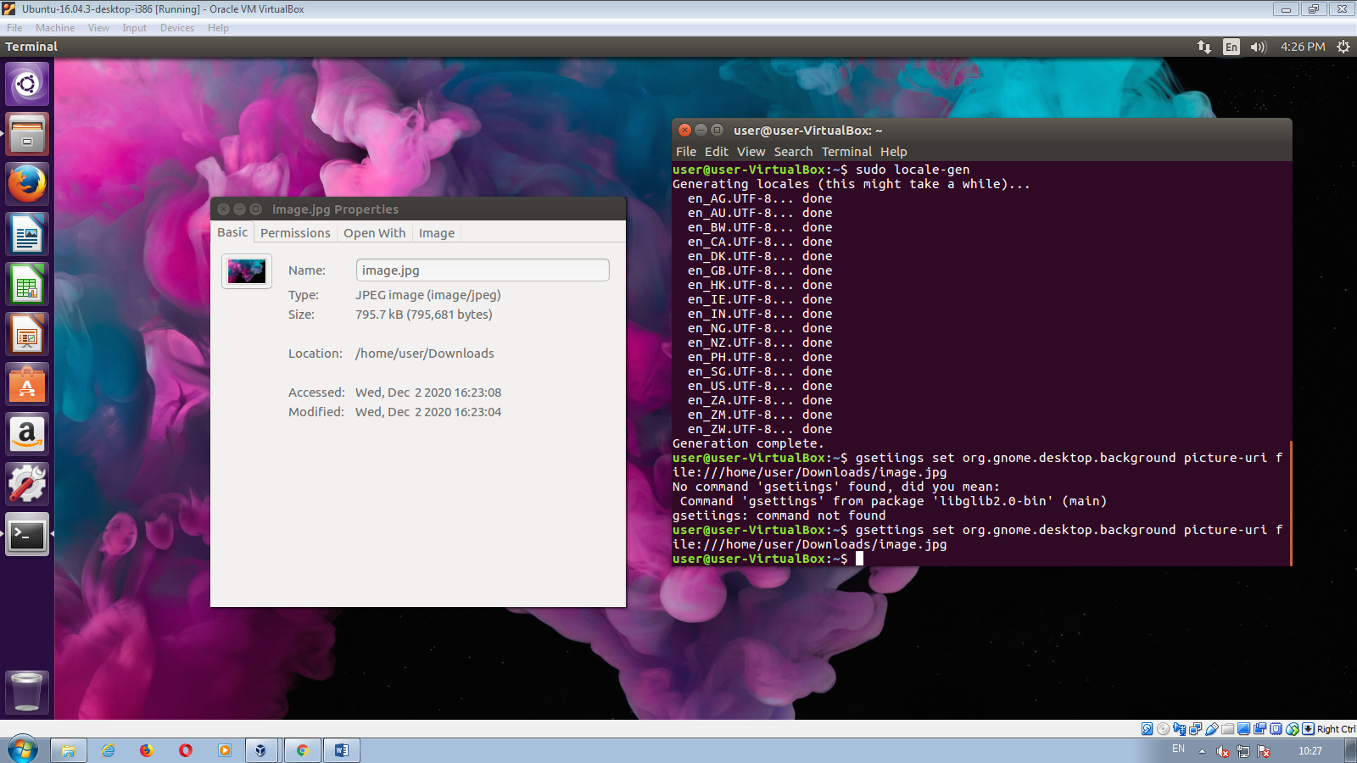

5.

System Settings > Appearance > Behavior > Auto Hide Launcher

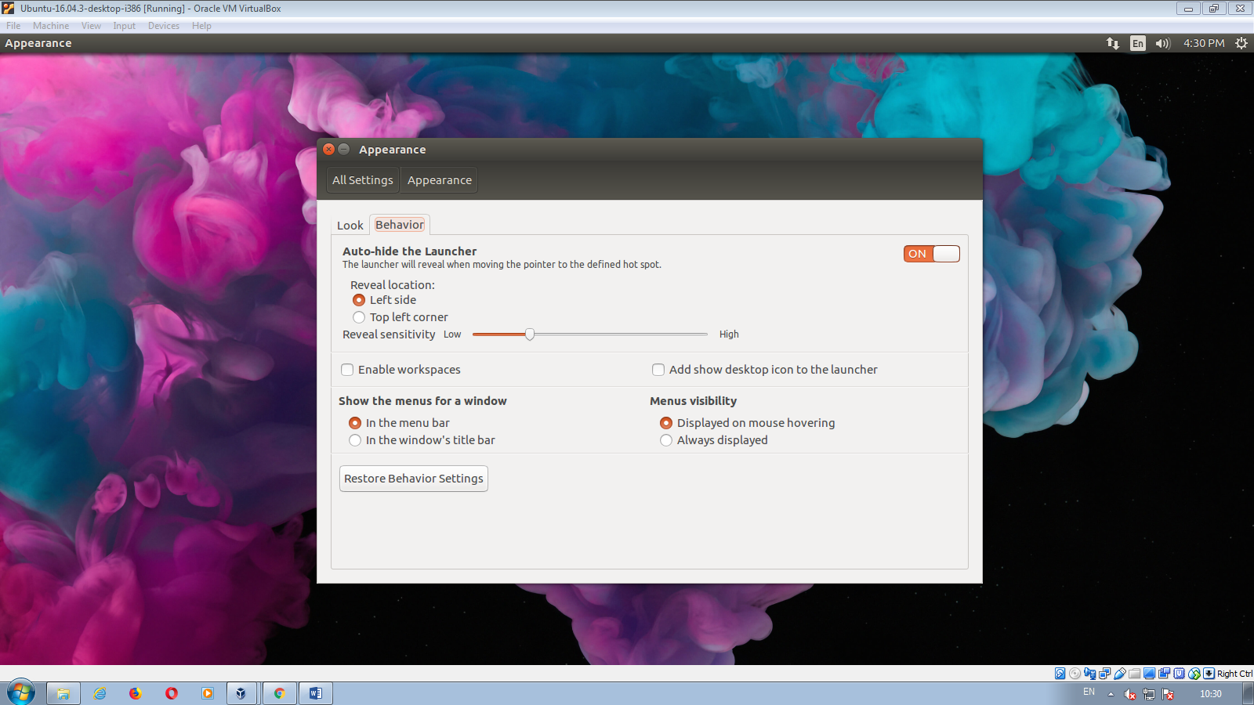

6.

7.

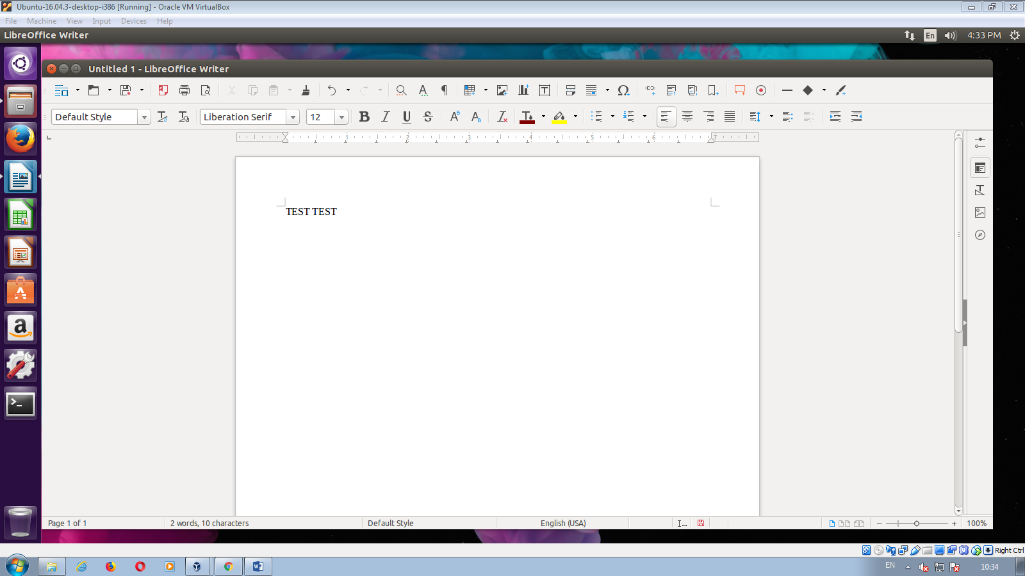

8.

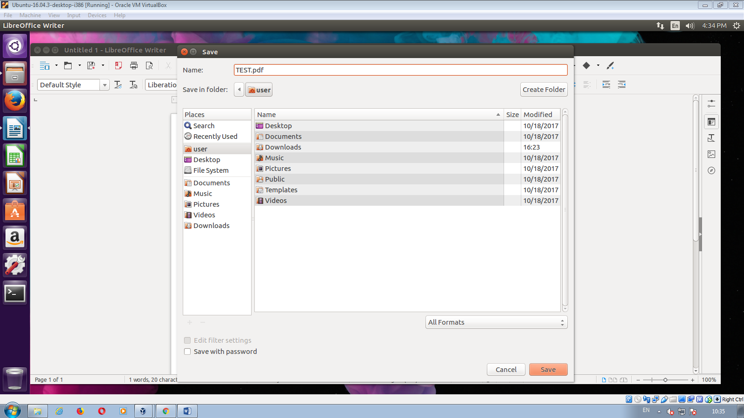

9.

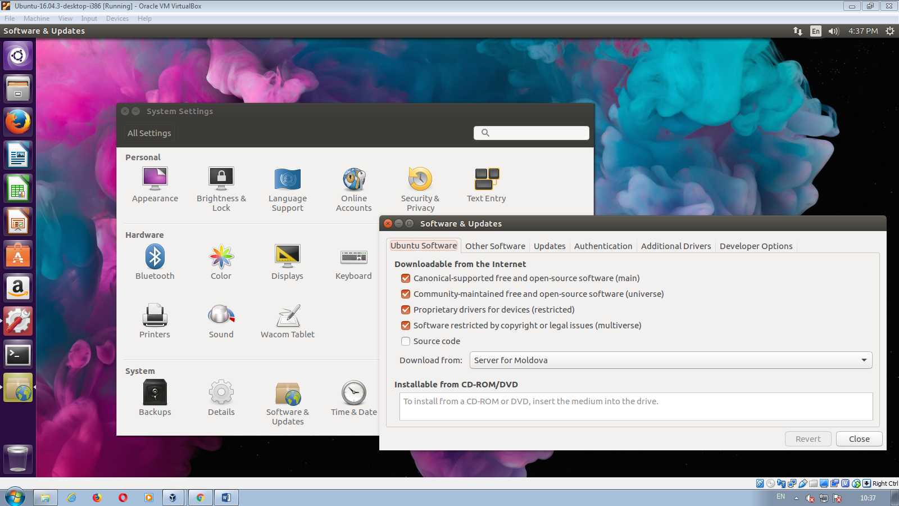

10.

sudo add-apt-repository ppa:ubuntuhandbook1/audacity

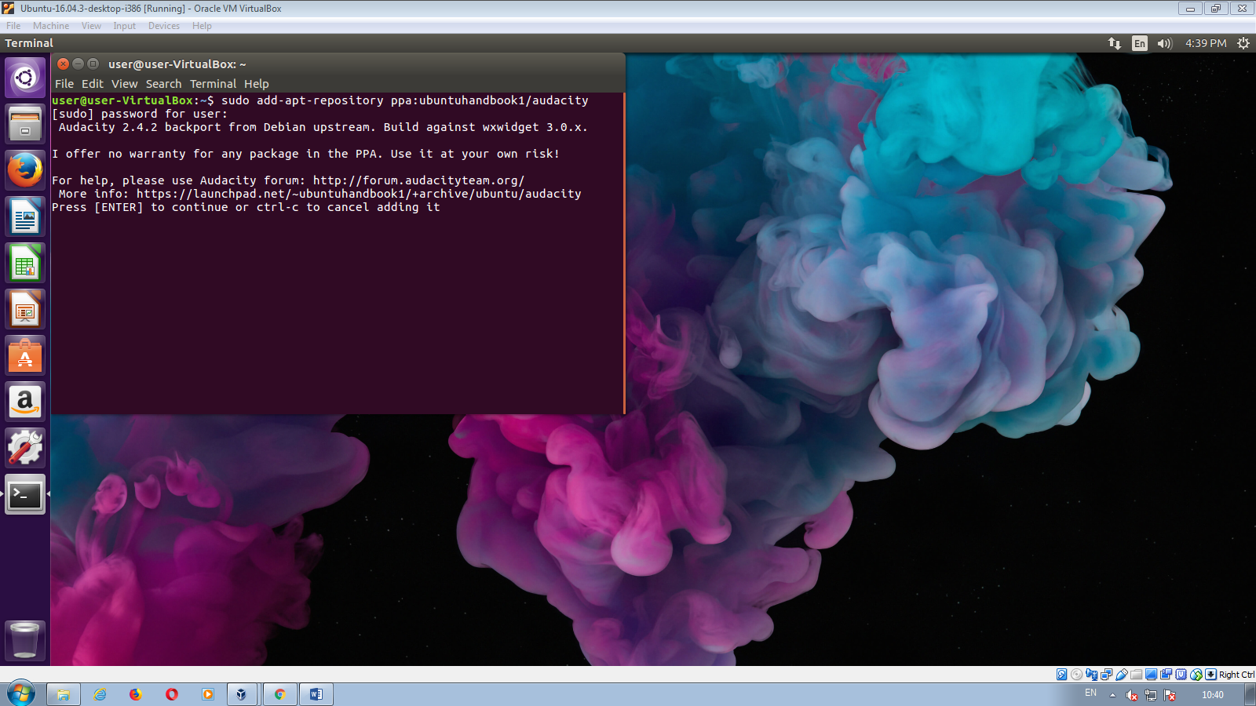

11.

$ find ~ -iname '\*.pdf'

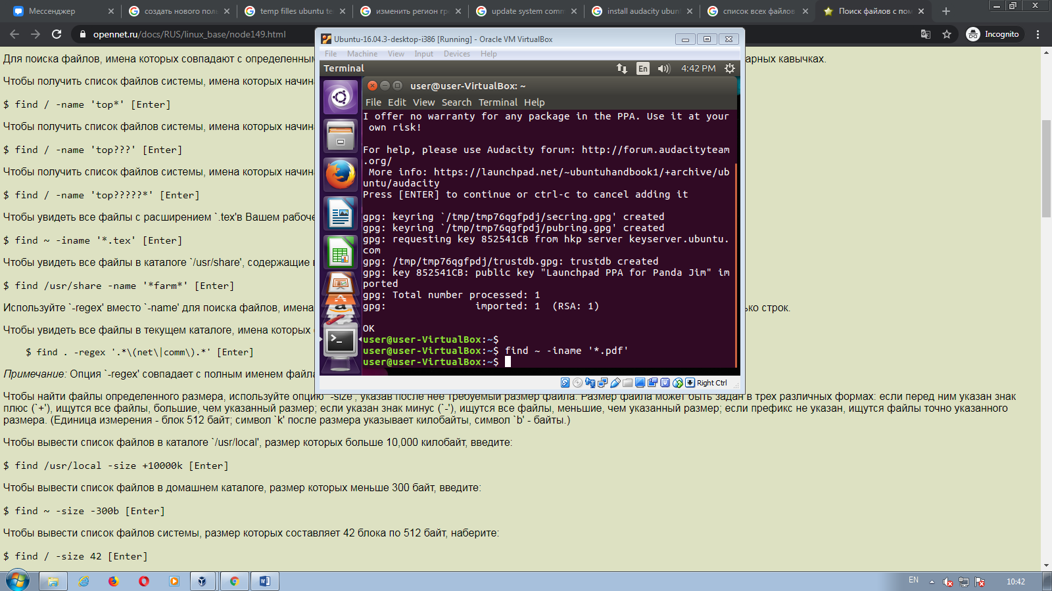

12.

Sudo chmod –R a+rwx /path (directoriul)

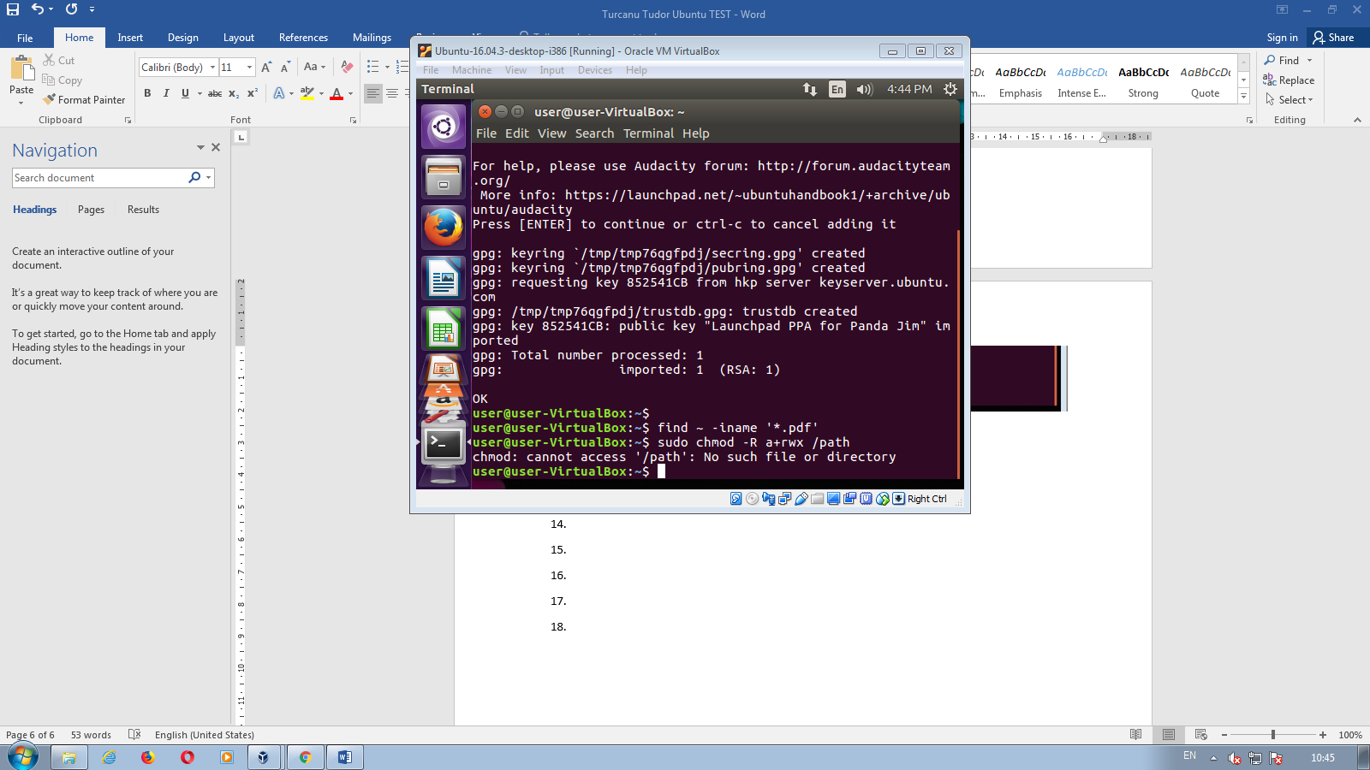

13.

sudo apt install zip

zip -p pass123 ccat-command.zip ccat-1.1.0 /

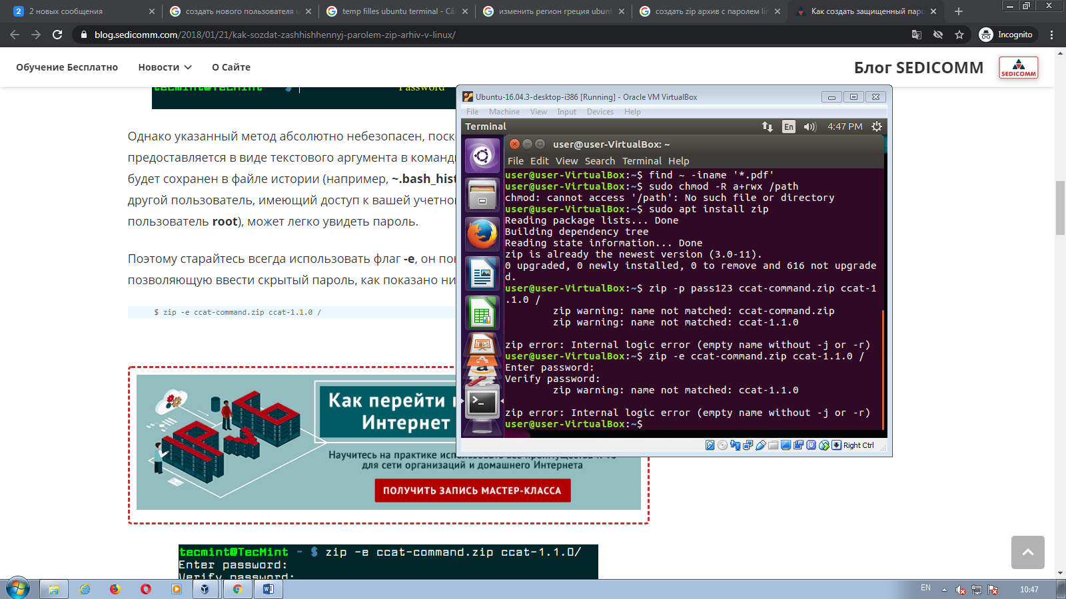

14.

sudo lshw -C memory

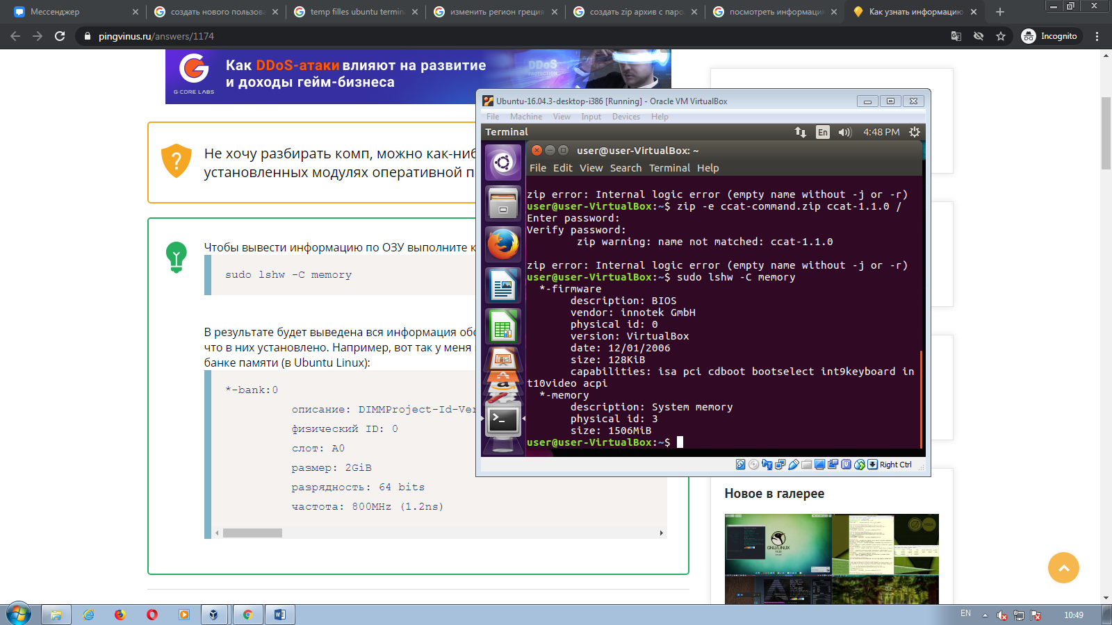

15.

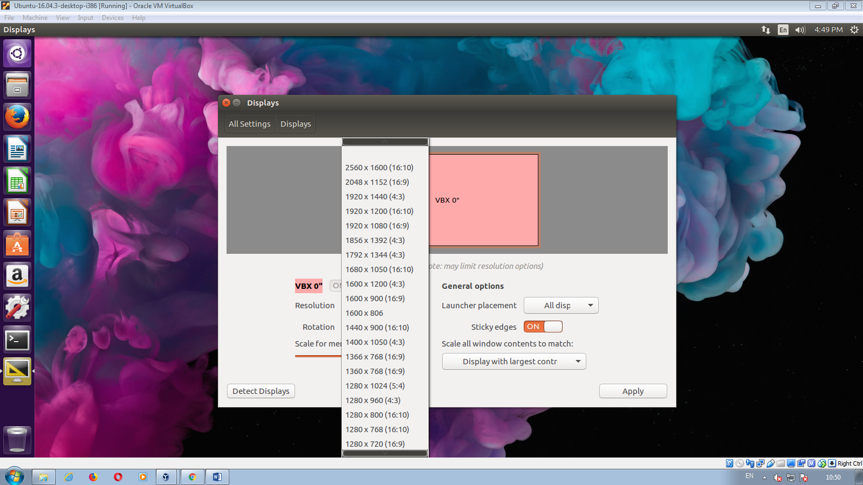

16.

Sudo apt-get update

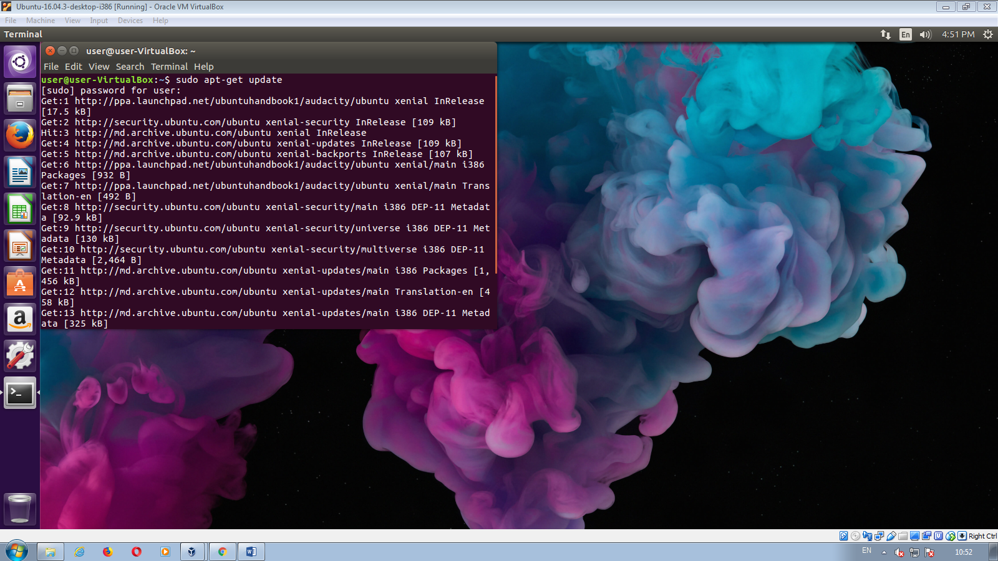

17.

Sudo apt-get install gparted  
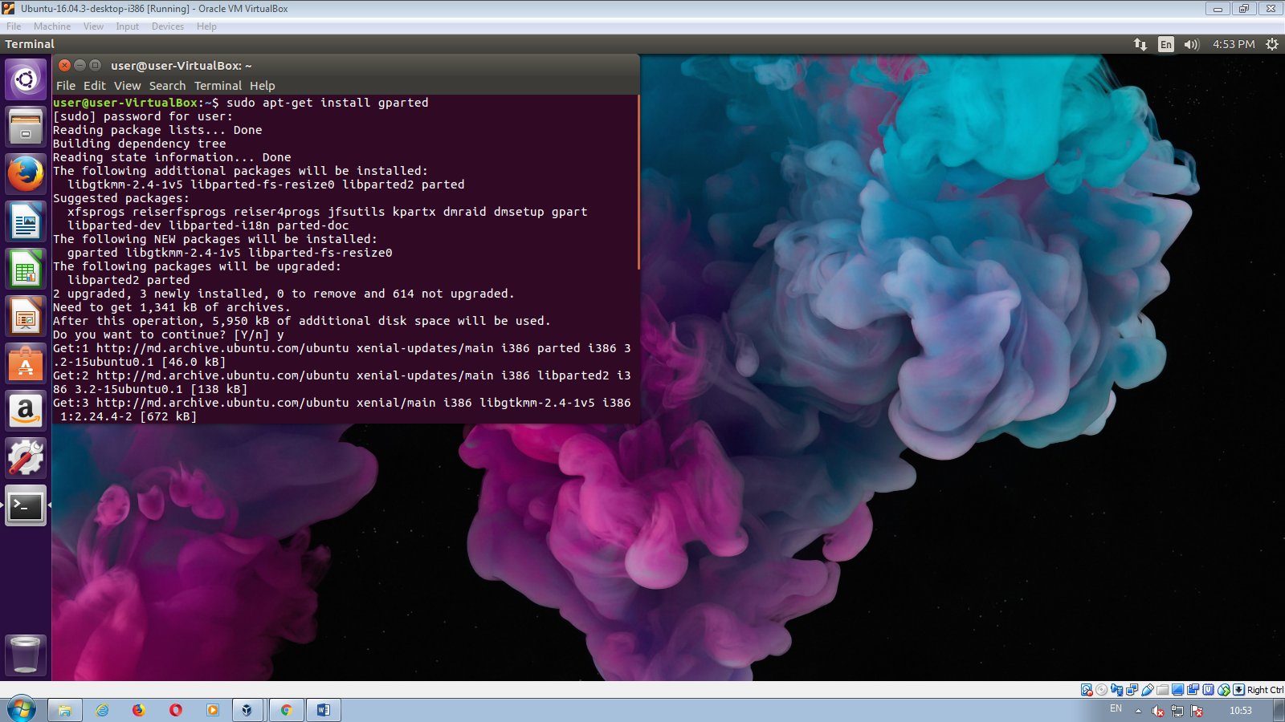

18.  
Nano

Scriem

#!/bin/bash

Cat oldfile | sed –e “s/testpattern/$REPL/g” > newfile

Salvam

Dupa “cmod 755 try.sh”

./try.sh